GOMBE STATE UNIVERSITY
FACULTY OF SCIENCE
DEPARTMENT OF COMPUTER SCIENCE

SIWES REPORT
BY
MUSA INUWA
REG. NO: UG22/SCCS/2021

MAY, 2025

declaration

I here declared that this work is the product of my training effort, undertaken under the supervision of Mr.…………………………. and has not been presented and will not be presented elsewhere for the fulfillment of my industrial training requirement.

MUSA INUWA
Student’s Name Signature Date

CERTIFICATION

This is to certify that the report was carried out under my supervision.

____________ ___________ ____________
Supervisor Signature Date

DEDICATION

I dedicate this work to GOD Almighty for His Love, grace, guidance and favor upon my life throughout the period of my industrial training, and with great pleasure and gratitude, I wish to dedicate this report to my beloved parents, siwes coordinator, and siwes supervisor and also to my friends and loved ones.

ACKNOWLEDGEMENTS

I sincerely thank the almighty Ar-rahaman for his infinite mercy for keeping me alive and healthy throughout the siwes period.

my special gratitude and respect goes to my beloved parents, family and friends for their prayers, support and guidance during my industrial training.

I also wish to express my appreciation and gratitude to my mentor Dr. Abdullahi Yarma, gombe state university and NIGT software solution for the opportunity I gained to perform my industrial training successfully in which I acquire some skills and knowledge during the training. I would also like to say a big thank to my industry-based supervisor and various staffs for their support and guidance that I carried out my work successfully so that I would gain some certain skills during the training.

at last, I would like to thank the head of department and the staffs computer science department especially my departmental based supervisor Mr. …………………………………………. as well as those who took part in making me successful throughout the work.

SIWES ITF Report
Table of Contents
1. Introduction
- 1.1 Background of the Study
- 1.2 Objectives of the Industrial Training
- 1.3 Scope of the Training
- 1.4 Significance of the Training
2. Organization Profile
- 2.1 Overview of Place of Establishment
- 2.2 History of NGIT Software Solutions
- 2.3 Role of the Place of Establishment
3. Weekly Activities and Learning Outcomes
- 3.1 Week 1-4: Introduction to ICT and Data Analysis
- 3.2 Week 5-8: Fundamentals of Web Development
- 3.3 Week 9-12: Advanced Web Development
- 3.4 Week 13-16: Networking and Server Management
- 3.5 Week 17-20: Computer Science Online Forum Discussion forum
- 3.6 Week 21-24: Final Review and Documentation
4. Challenges and Solutions
- 4.1 Challenges Encountered
- 4.2 Solutions and Lessons Learned
5. Conclusion and Recommendations
- 5.1 Summary of IT Experience
- 5.2 Recommendations for Future IT Students
- 5.3 Personal Reflections
- 5.4Challenges and Solutions

CHAPTER ONE: INTRODUCTION
1.1 Background of the Study
The Student Industrial Work Experience Scheme (SIWES) is a program initiated by the Industrial Training Fund (ITF) to bridge the gap between theoretical knowledge and practical skills in tertiary institutions. As a Computer Science student, I undertook my industrial training at NGIT Gombe, located at Tashan Dukku Layol Plaza ICT Centre.
During my training, I gained hands-on experience in data analysis using Microsoft Excel, web design and development, networking, and project execution, particularly on a computer science online discussion forum development project.
1.2 Objectives of the Industrial Training
- The objectives of the industrial training include:
- To gain practical experience in data analysis using Microsoft excel.
- To acquire skills in web development, including HTML, CSS, Bootstrap, and PHP.
- To understand the fundamentals and implementation of networking.
- To apply theoretical knowledge to solve real-world problems.
- To develop a project that integrates acquired skills.
1.3 Scope of the Training
The training encompassed a range of activities, including:
- Creating a simple’s spreadsheet using Microsoft Excel for various applications.
- Developing websites and web applications using HTML, CSS, Bootstrap, and PHP.
- Configuring and troubleshooting network systems.
- Managing servers and databases.
- Designing and implementing a computer science online discussion forum.

1.4 Significance of the Training
The training significantly enhanced my practical skills, improved my problem-solving abilities, and prepared me for future professional challenges in the field of Computer Science. It also provided exposure to industry-standard tools and technologies, such as Microsoft Excel for data analysis and PHP for web development.

CHAPTER TWO: ORGANIZATION PROFILE
2.1 Overview of Place of Establishment
NGIT Gombe is an ICT training and consultancy center located in Tashan Dukku Layol Plaza, Gombe. The center specializes in web development, graphics design, networking, and ICT solutions for businesses and individuals. The organization prides itself on providing industry-relevant training and bridging the gap between theoretical knowledge and practical skills.
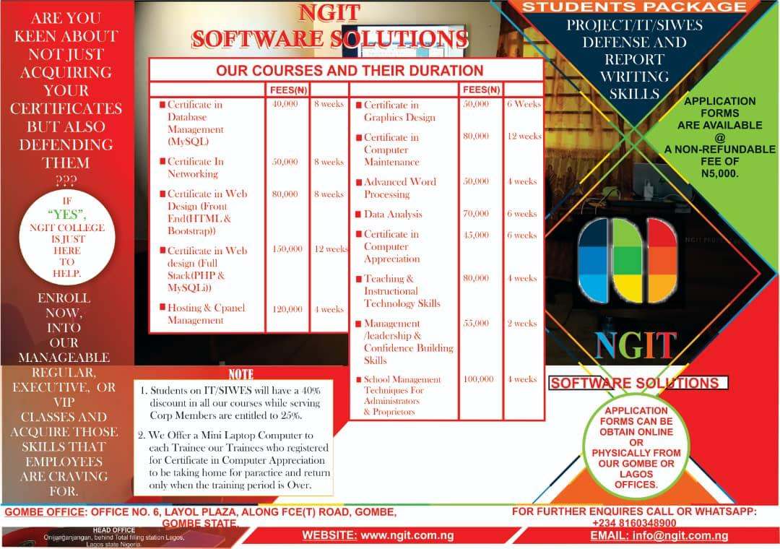
2.2 History of NGIT Software Solutions
NGIT Software Solutions was established in 2010 with a vision to provide cutting-edge ICT solutions and training to individuals and organizations. Over the years, NGIT has grown into a reputable institution, offering a wide range of services including software development, networking solutions, and IT consultancy. The organization has successfully trained thousands of students and professionals, contributing significantly to the development of the ICT sector in Nigeria.
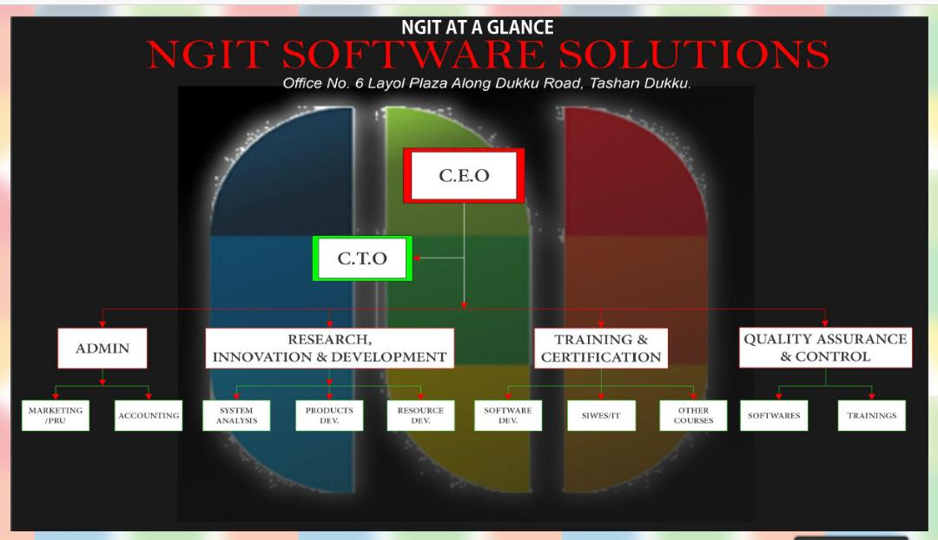

2.3 Role of the Place of Establishment
NGIT Gombe plays a vital role in equipping students and professionals with practical ICT skills. The center provides hands-on training in graphics design, web development, networking, and other ICT-related fields, fostering the growth of skilled professionals in the industry. It also serves as a hub for innovation, enabling trainees to work on real-world projects and gain valuable experience.

CHAPTER THREE: WEEKLY ACTIVITIES AND
LEARNING OUTCOMES
3.1 Week 1-4: Introduction to ICT and Data Analysis
- Orientation and familiarization with NGIT’s operations.
- Introduction to Microsoft Excel and PowerPoint and learning the Excel interface: ribbon, workbook and worksheet.
- Learning basic PowerPoint interface: slides themes, transition and presentation view.
- Working with Excel Formulas and Slide Design learned basic Excel function formulas: SUM, AVARAGE, MIN MAX.
- Intermediate Excel Skill and PowerPoint animation learned to use Excel IF, 1COUNTIF, VLOOKUP.
- In PowerPoint, practiced using animation effect on text and images

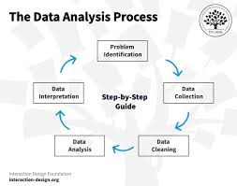

3.2 Week 5-8: Fundamentals of Web Development
- Introduction to web development using HTML and CSS.
- Learning the basics of Bootstrap for creating responsive web designs.
- Designing simple static/c web pages and understanding layout techniques.
- Introduction to PHP for backend development.
- Hands-on practice with form creation and validation using HTML and PHP.

3.3 Week 9-12: Advanced Web Development
- Developing dynamic websites using PHP and integrating databases.
- Implementing user authentication and session management.
- Working on small web projects to apply learned concepts.
- Enhancing web pages with Bootstrap and PHP for interactivity.
- Exploring web hosting and deployment processes.
- 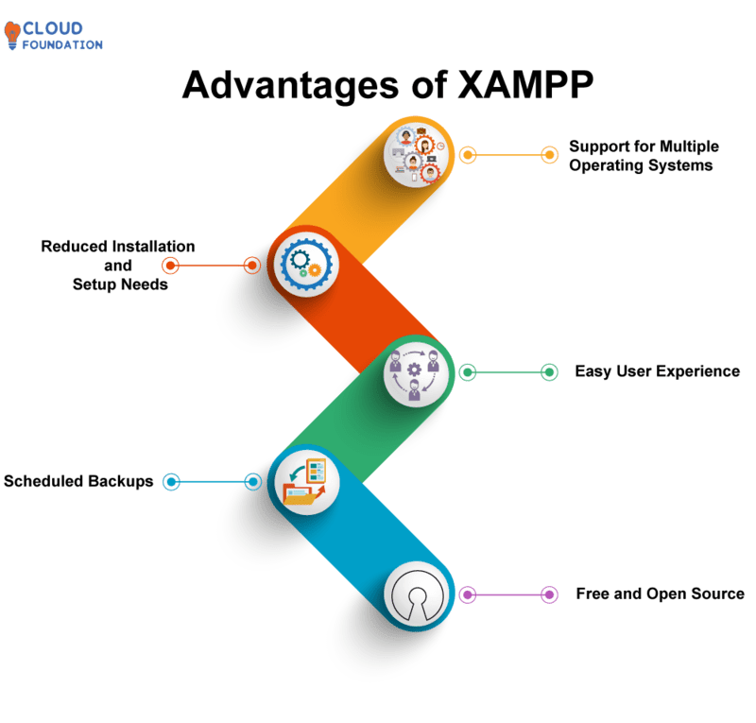

3.4 Week 13-16: Networking and Server Management
- Setting up and managing network configurations.
- Learning about network protocols, security, and optimization.
- Configuring routers and troubleshooting network issues.
- Hands-on experience with server setup and maintenance.
- Exploring cloud networking and virtualization techniques.

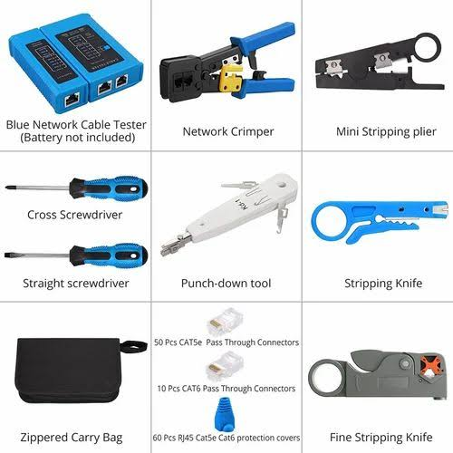
3.5 Week 17-20: Computer Science Online Discussion Forum Project:
- Researching requirements for user discussions, replies, likes, and topics management.
- Designing the user interface using HTML and Bootstrap for a responsive and clean layout.
- Developing the backend using PHP to handle user submissions, topic filtering, replies, likes, and retweets.
- Testing the forum for functionality, usability, and security (e.g., input validation and proper redirects)
- Integrating a MySQL database for storing discussions, replies, and user interactions.
3.6 Week 21-24: Final Review and Documentation
- Reviewing and refining the Computer Science Discussion Forum.
- Documenting the entire project process and creating user manuals.
- Preparing the final IT report and presentation.
- Conducting a comprehensive evaluation of the training experience.
- Registration form:

Home Page:
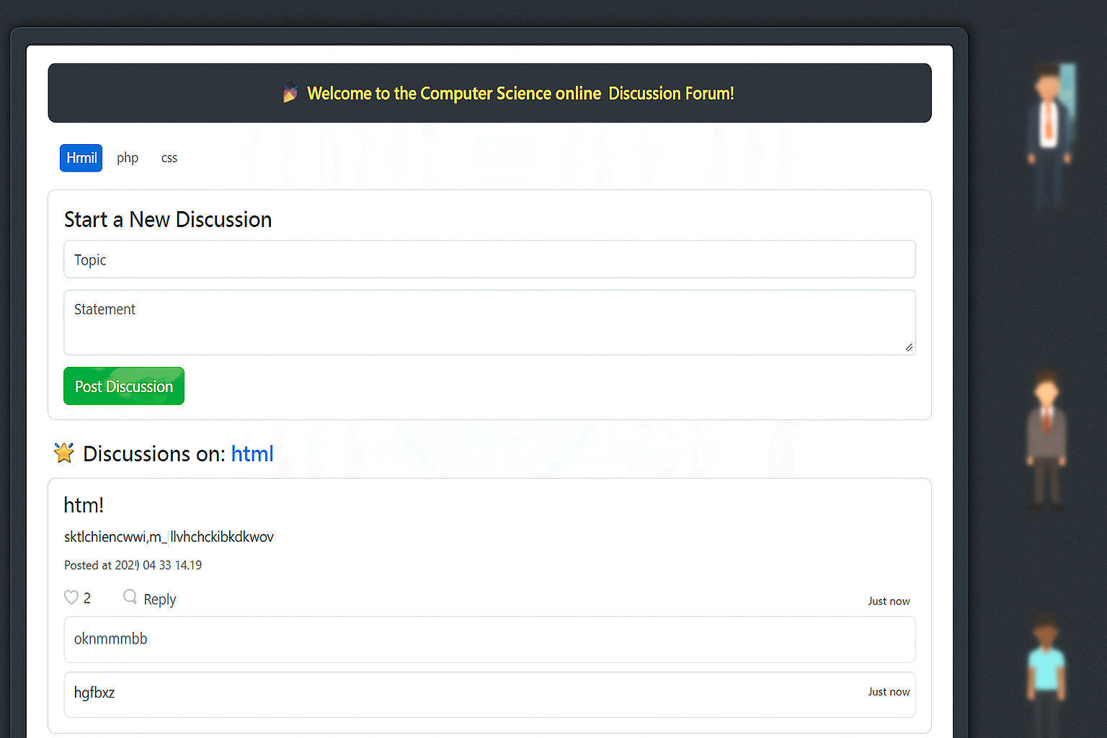
CHAPTER FOUR: CHALLENGES AND SOLUTIONS
4.1 Challenges Encountered
- Difficulty mastering Microsoft Excel: IF, COUNTIF, VLOOK for advanced Excel function.
- We experienced electrical issues because of national grid have a problem.
- Debugging complex PHP scripts in web development.
- Troubleshooting network connectivity issues in real time scenarios.
- Managing time effectively between different tasks and deadlines.
- Ensuring cross-browser compatibility for web applications.

4.2 Solutions and Lessons Learned
- Attending additional tutorials and seeking guidance from mentors.
- Leveraging online resources and communities for problem-solving.
- Conducting step-by-step troubleshooting for networking problems.
- Implementing effective time management strategies and prioritizing tasks.
- Using debugging tools and browser developer tools for testing.

CHAPTER FIVE: CONCLUSION AND
RECOMMENDATIONS
5.1 Summary of IT Experience
The industrial training at NGIT Gombe was an enriching experience that bridged the gap between theoretical knowledge and practical application. I gained valuable skills in Data Analysis using Microsoft Excel, web development with HTML, CSS, Bootstrap, and PHP, networking, and project management, culminating in the development of a weather application. This experience has significantly contributed to my professional growth and readiness for the ICT industry.
5.2 Recommendations for Future IT Students
- Engage actively in all training activities and practice regularly.
- Seek guidance from mentors and leverage online resources for advanced learning.
- Focus on completing a project to apply acquired skills.
- Allocate time effectively to balance different aspects of training.
- Embrace challenges as opportunities for growth and learning.
5.3 Personal Reflections
This experience has been instrumental in shaping my professional journey. It provided me with the confidence and skills needed to excel in the ICT field and prepared me for future challenges. The integration of graphics design, web development, and networking into my training was particularly impactful, broadening my skill set and enhancing my career prospects. The mentorship and collaborative environment at NGIT Gombe were invaluable in ensuring a fulfilling learning experience.

Reference
- Microsoft. (n.d.). Excel Documentation. Retrieved from https://support.microsoft.com/en-us/excel
- W3Schools. (n.d.). HTML Tutorial. Retrieved from https://www.w3schools.com/html
- W3Schools. (n.d.). CSS Tutorial. Retrieved from https://www.w3schools.com/css
- Bootstrap. (n.d.). Introduction to Bootstrap. Retrieved from https://getbootstrap.com/docs/5.0/getting-started/introduction/
- PHP Manual. (n.d.). PHP: Hypertext Preprocessor. Retrieved from https://www.php.net/manual/en/
- MySQL. (n.d.). MySQL 8.0 Reference Manual. Oracle. Retrieved from https://dev.mysql.com/doc/

